# Apache Superset Installation

Please follow the commands mentioned below to install apache superset.

## Ubuntu(Windows by Enabling Linux Subsystem For Windows)

**Step 1: Download and install Ubuntu from windows Store.**

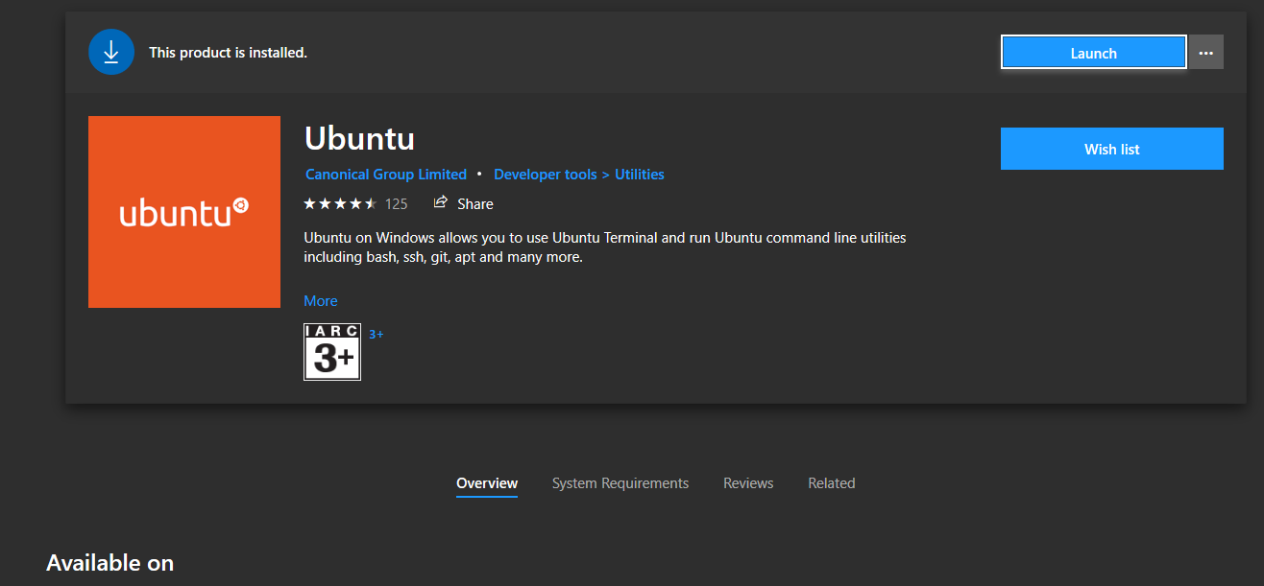

**Step 2: Goto Turn Windows Features on or off (just by searching)**

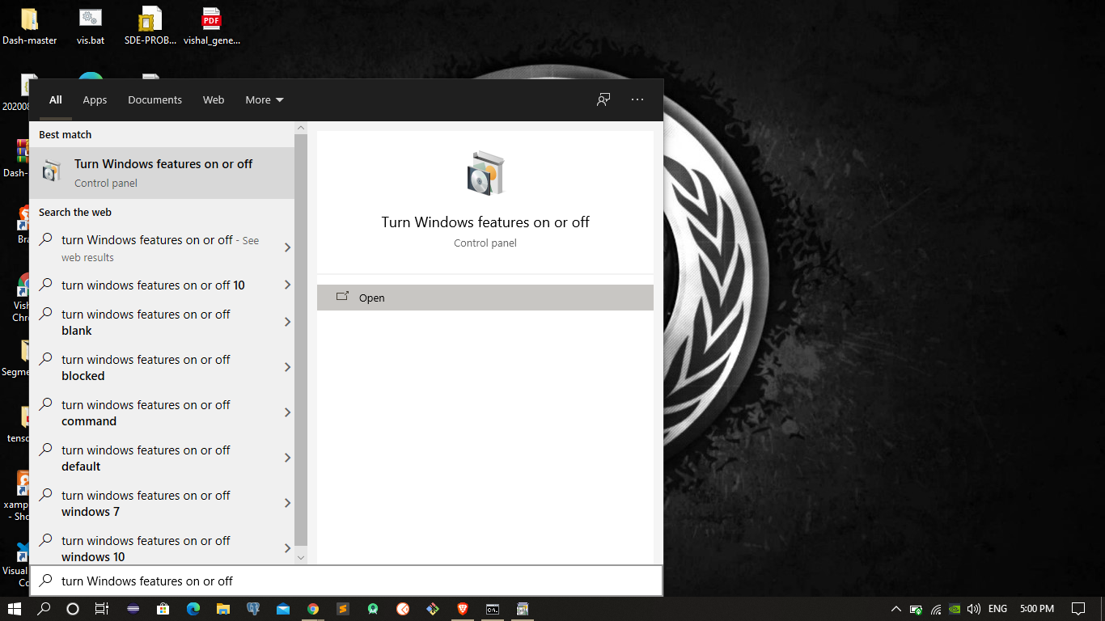

**3. Select the Windows Subsystem for Linux and then press ok**

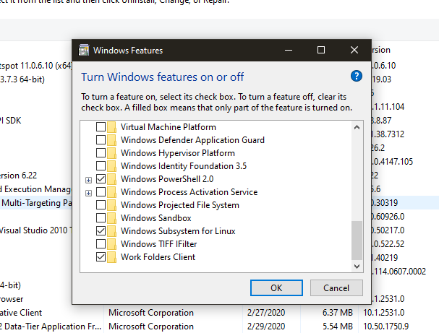

**Note :- After that make sure you have turned on Developer mode for windows some time you might face some issue .**

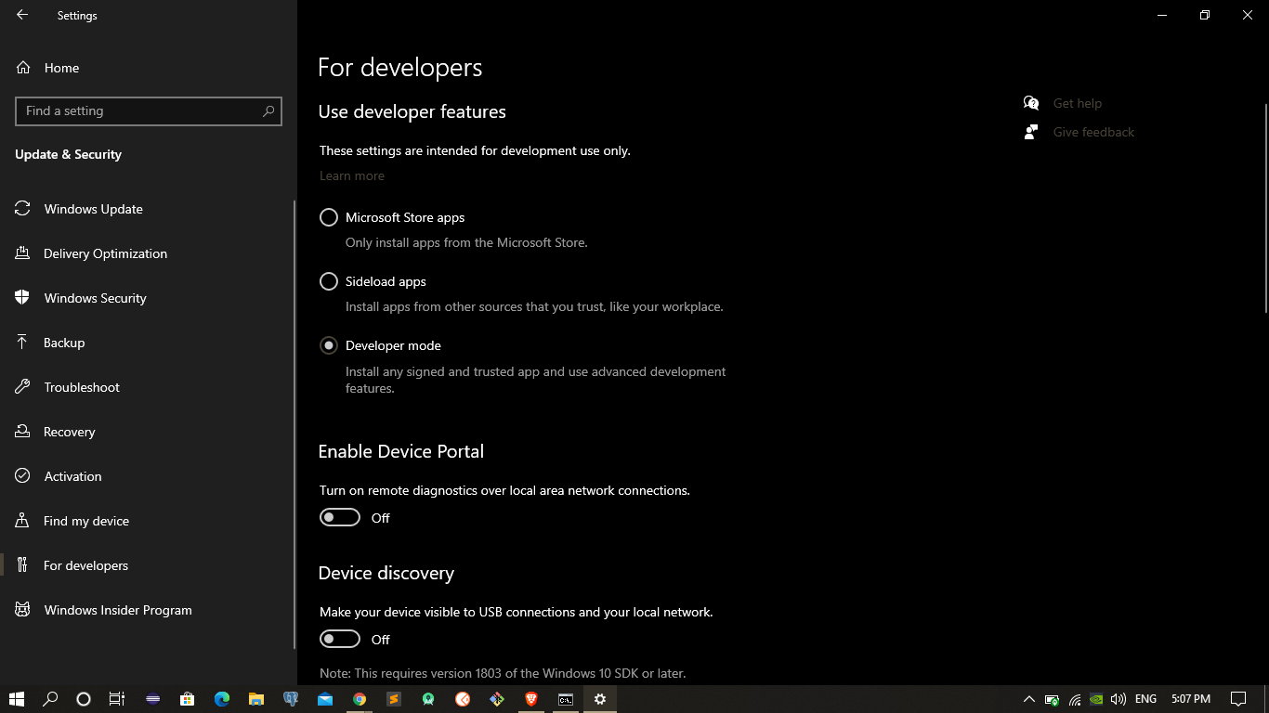

**After that open the ubuntu which you have installed.And enter the username & password**

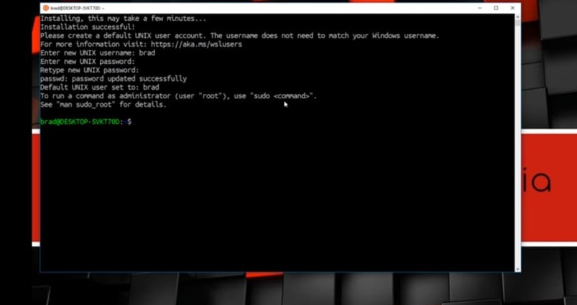

**After that enter the commands in ubuntu :-**

1. sudo apt update

2. sudo apt install python3-pip

3. pip3 --version

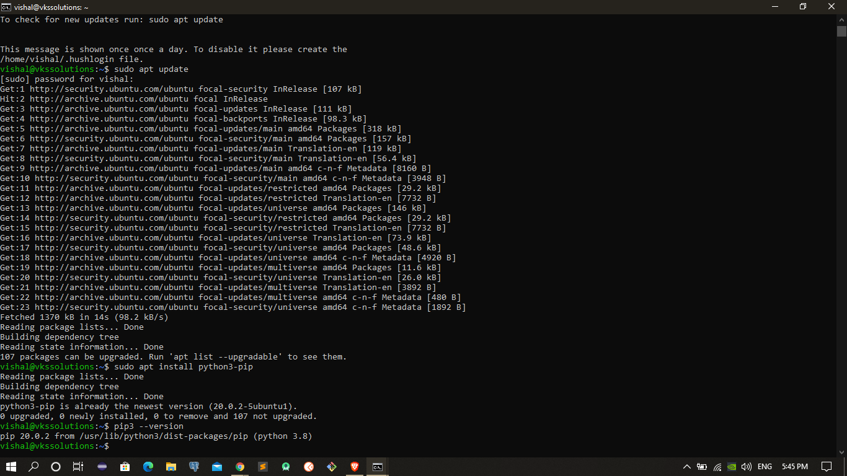

4. pip3 install virtualenv

5. sudo apt-get install python3-venv

6 python3 -m venv supersetdata

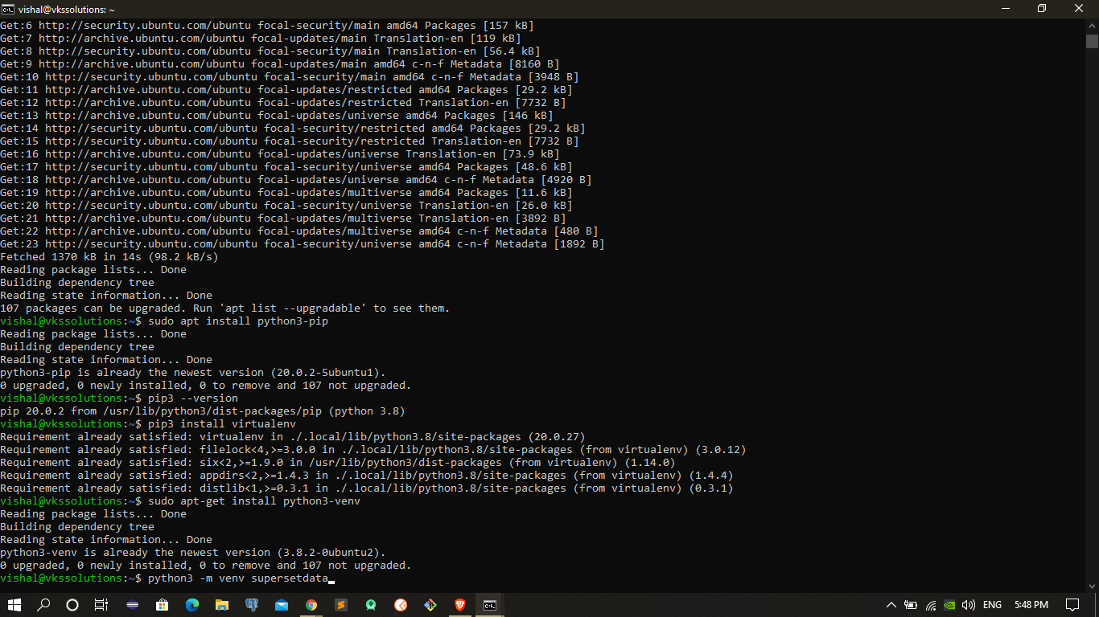

7. . supersetdata/bin/activate

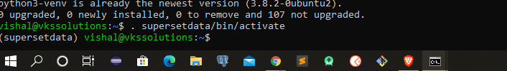

**After that enter these commands**

8. pip install --upgrade setuptools pip

9. pip install apache-superset

10. superset db upgrade

11. export FLASK_APP=superset

12. superset fab create-admin

( Username [admin]: admin

User first name [admin]: admin

User last name [user]: admin

Email [admin@fab.org]: xyz@gmail.com

Password:

Repeat for confirmation: )

13. superset load_examples

14. superset init

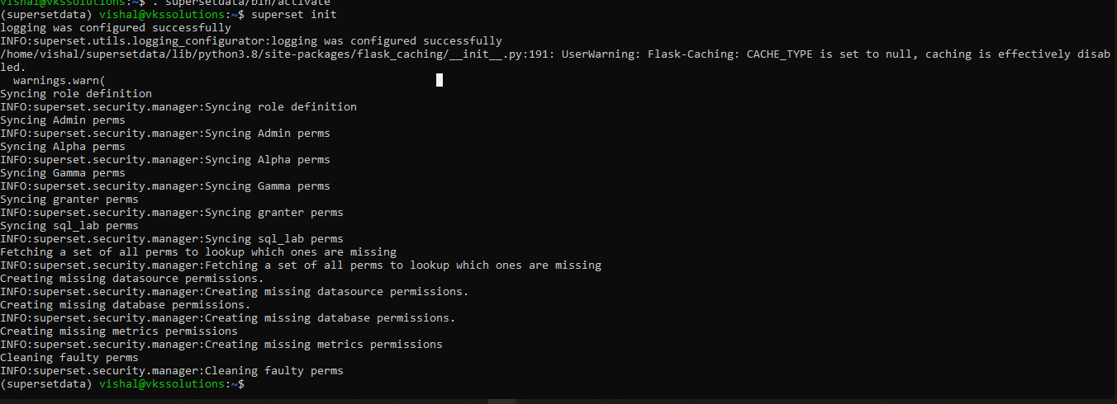

15. superset run -p 8088 --with-threads --reload --debugger

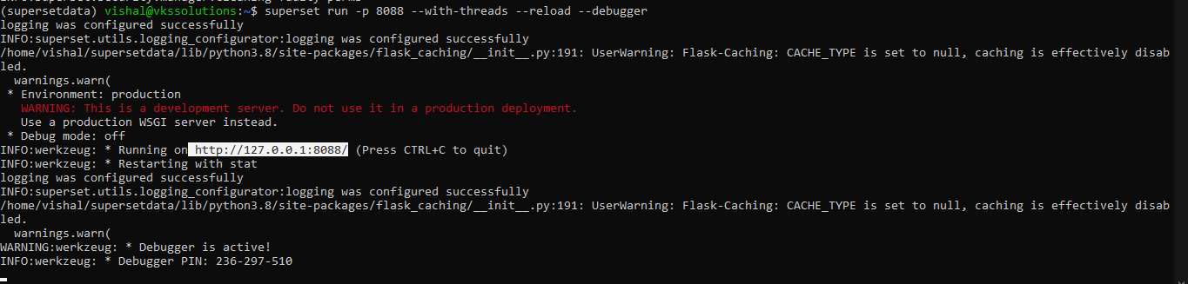

Enter the url in your Browser :- [**http://127.0.0.1:8088/**](http://127.0.0.1:8088/)

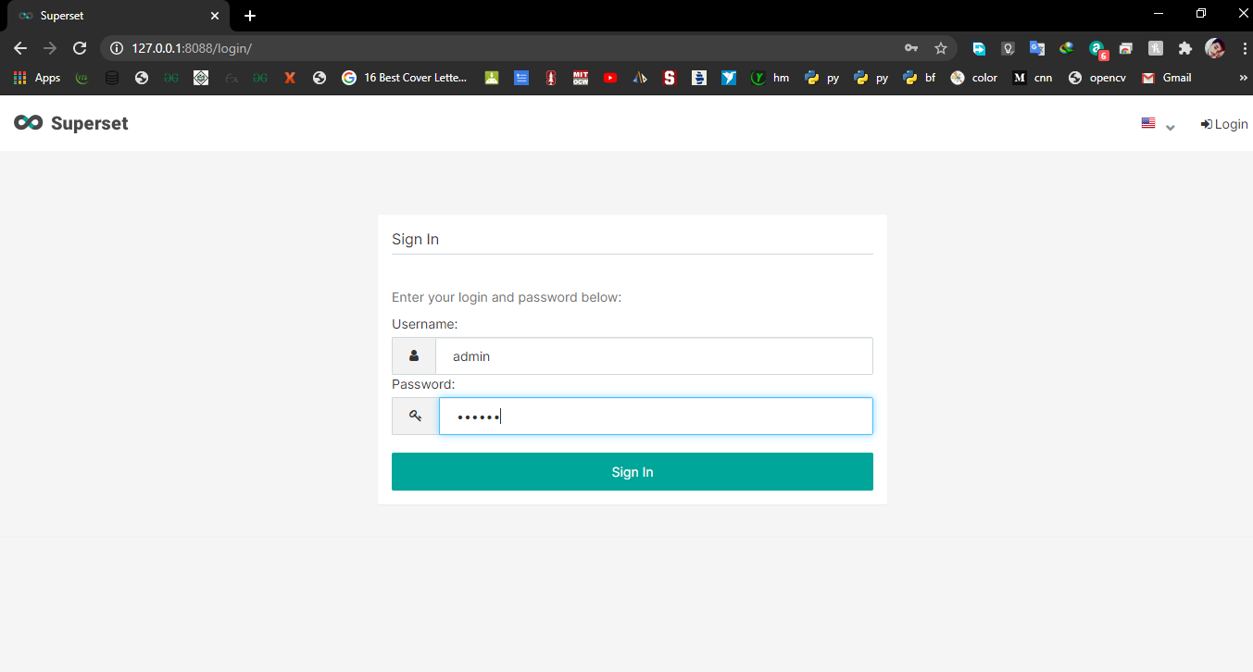

After Sign in you will see Dashboards Explore the DashBoards

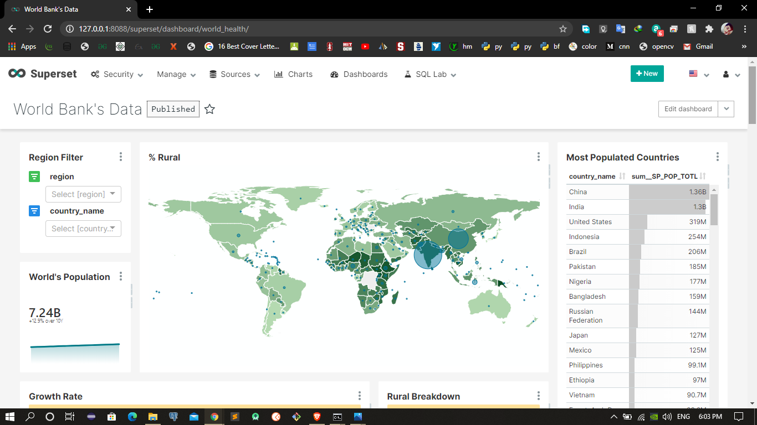

**How to Get MSSQL Data in PostgreSql ?**

Using (Foreign Data Wrapper) tds_fdw

**PostgreSql Installation**

Here I am using PostgreSQL 12 .([PostgreSql Download Link](https://www.enterprisedb.com/downloads/postgres-postgresql-downloads))

**tds_fdw installation and configuration**

You need to download suitable Binaries according to your Software.

For Binaries You can refer the below link .([Binary file link](https://github.com/yyjdelete/temp_storage/files/4605716/tds_fdw-pg_edb_12_winx64.zip))

(<https://github.com/tds-fdw/tds_fdw/issues/53#issuecomment-626329771>)

After downloading the binaries extract the Binary file .

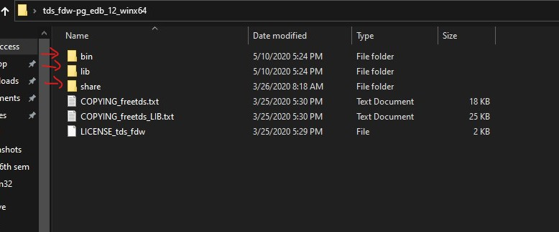

After that go to PostgreSql Folder in Program files and Paste the Binary file according to given instruction.

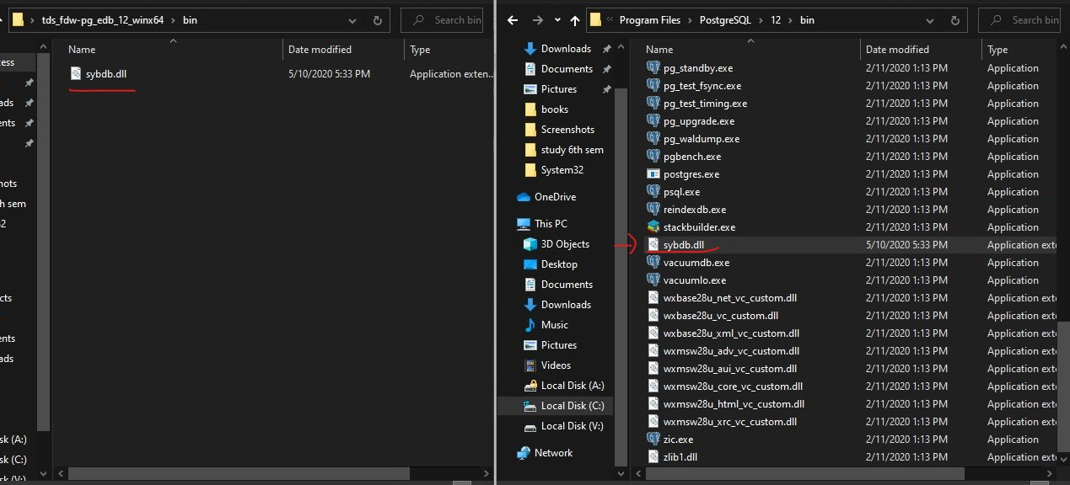

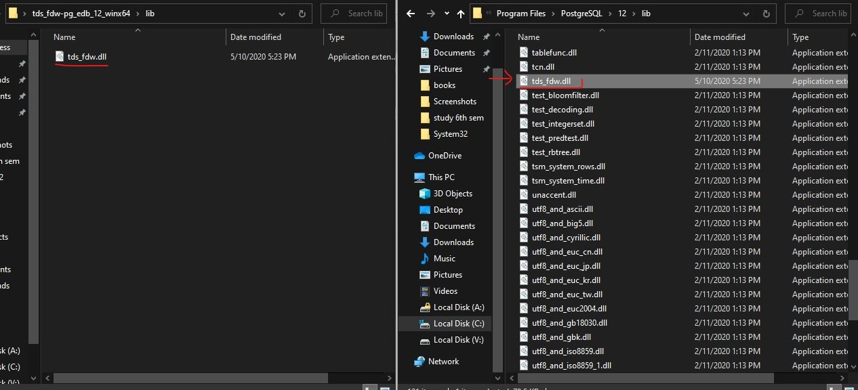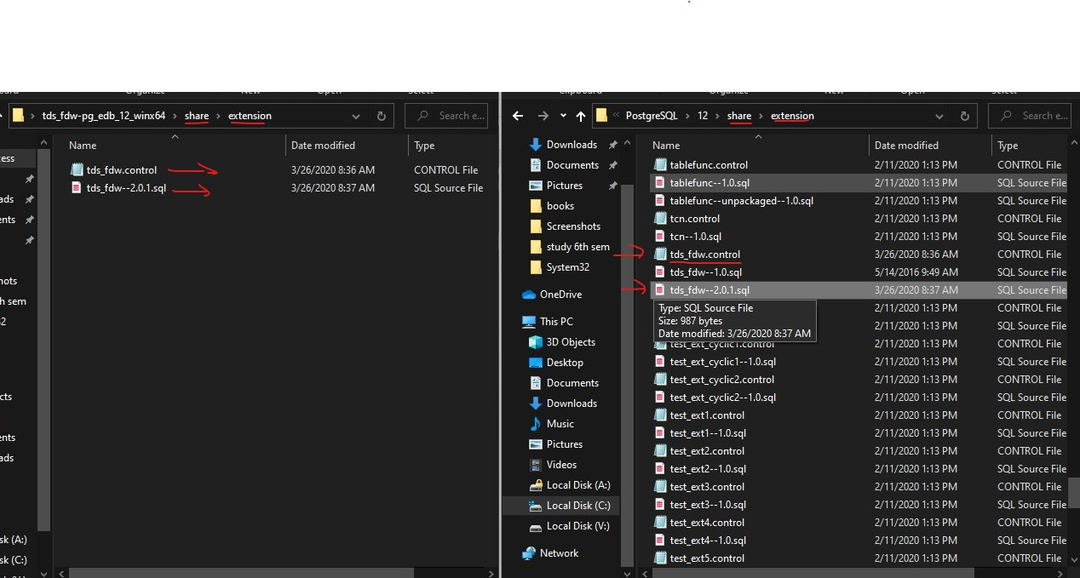

Before creating extension check **on which port your Ms sql server** is Running.

1. **Open SQL sever 2019(your version) configuration Manager.**

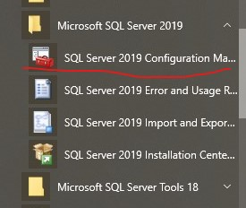

1. **Open the Sql Server 2019 configuration Manager**

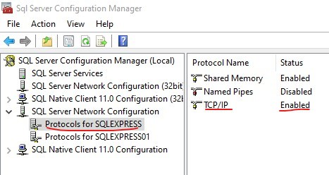

**Check TCP/IP is enabled.**

**3 Click on the TCP/IP and check on which port it is running** 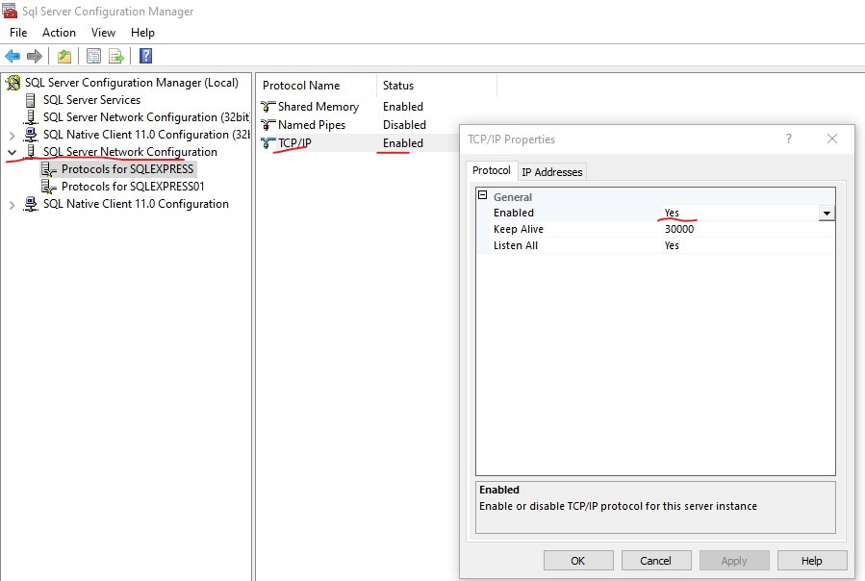

See if there is **port number** mentioned or not & click ok .

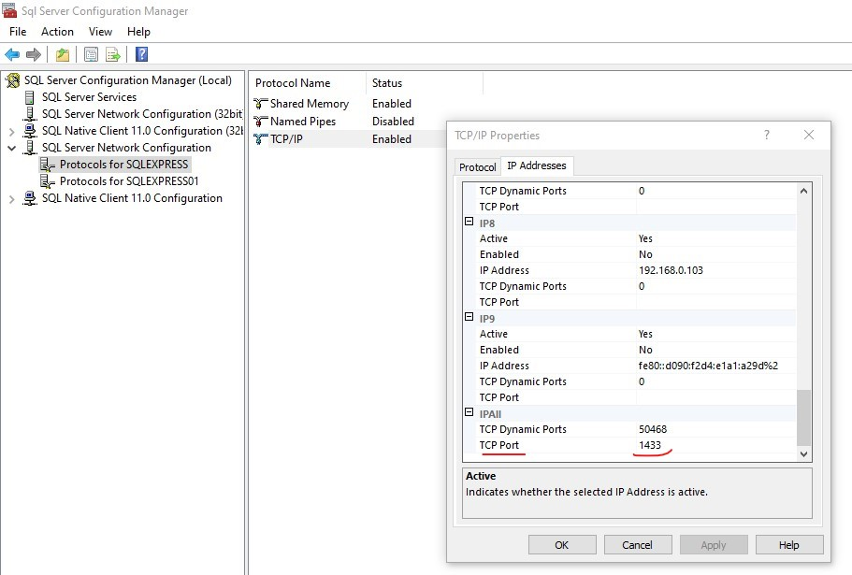

**After that restart the server.**

Click on the Sql server (which is running) and Restart it .

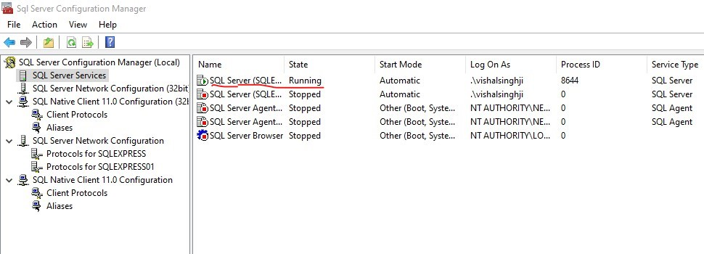

# MSSQL Table Creation and accessing in Postgres

**Open Microsoft SQL Server Management Studio 18**

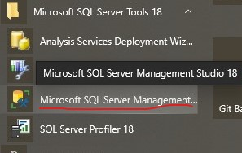

Open it and we are going to **create new user** first.

Go to login and click on it to create new user.

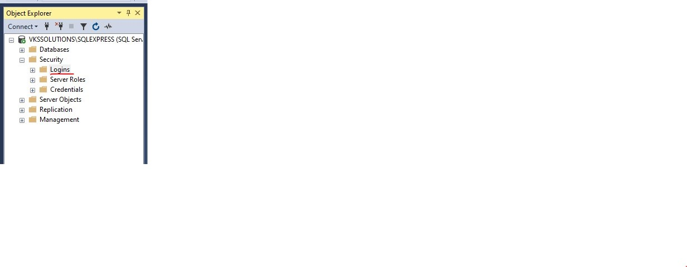

After that write the **UserName & Password** and give certain **permission of sysadmin**(to fetch all the database if you wish)

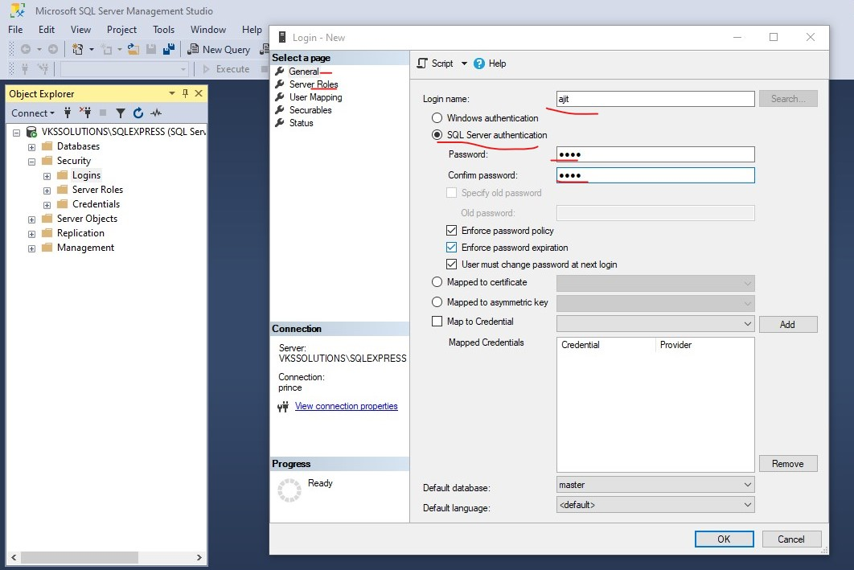

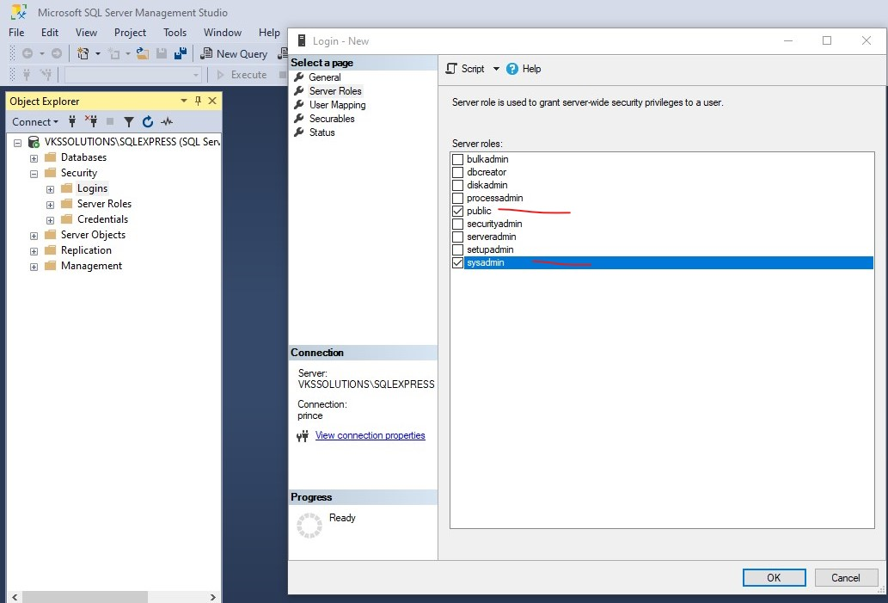

Press **Ok** and you will see a new user has been created.

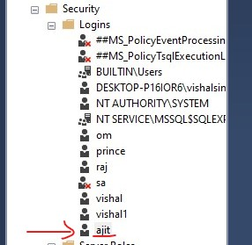

After that we are going to **log in** with the new user .

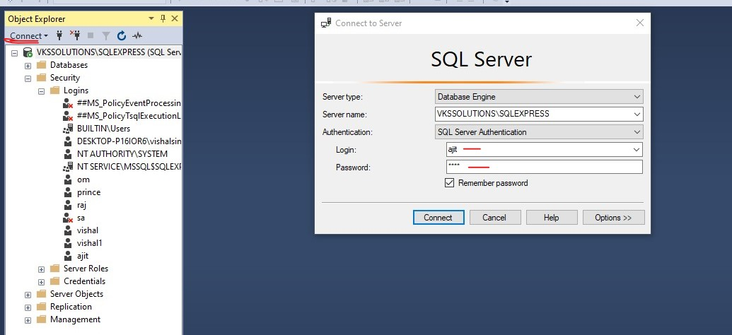

**As the new user it will ask for new password you can enter same password as you wish.**

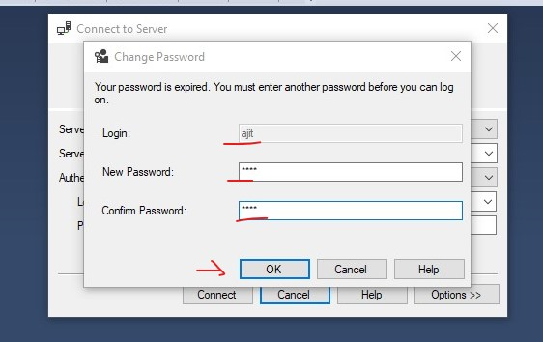

Press Ok you will find that you have signed into **MS SQL** with same **UserName**.

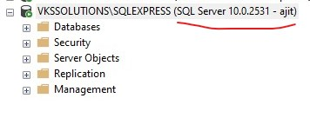

**So create one Database and Table .**

**Database Name** - Test

**Table Name**- employee (with 4 attributes)

**Schema** - dbo

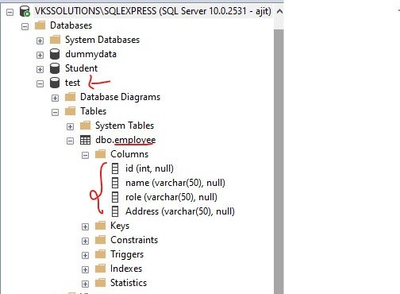

**After that we will go to PostgreSql we will create extension and try to fetch data using Foreign Data wrapper.**

1 **Create Database**

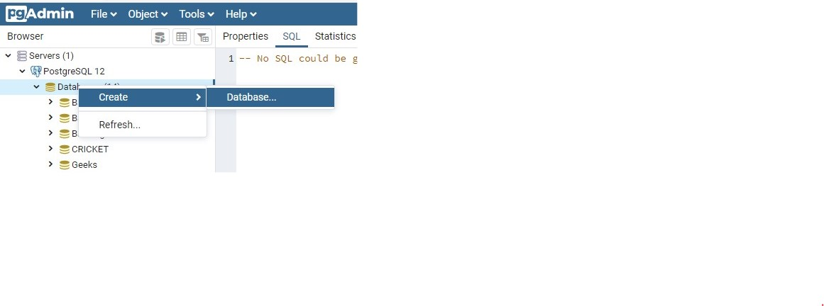

Enter the **DataBase Name and press Save**.

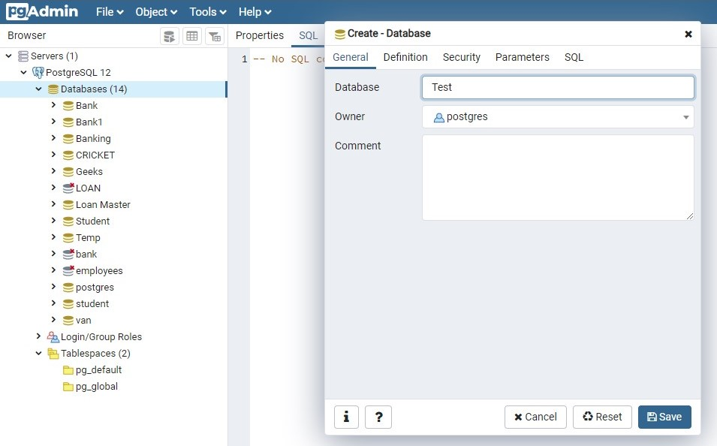

**After that you will find DatabaseName in Databases.**

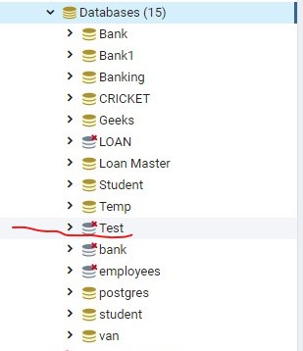

**Open Query tool**

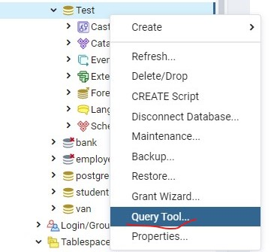

# We are going to create extension(tds_fdw)

I have followed this link for syntax reference([Syntax Link](https://tushar-postgresql.blogspot.com/2017/09/postgresql-foreign-data-wrapper-for-ms.html))

Step :1

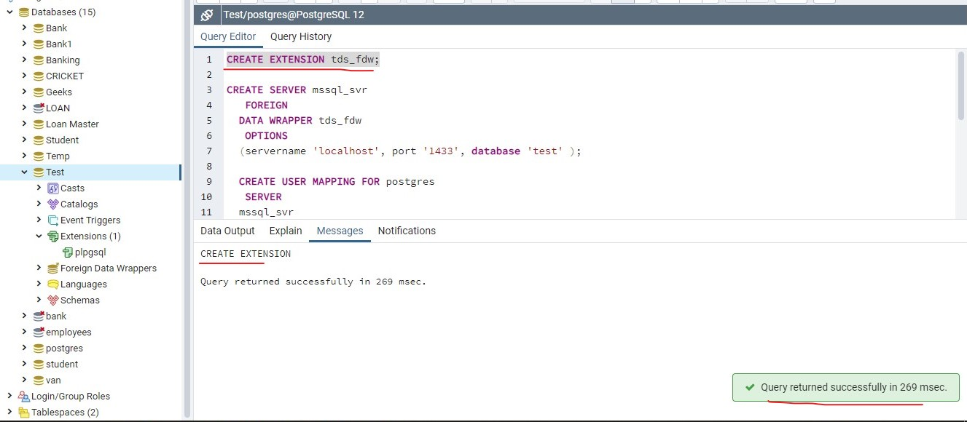

**After execution you can find extension.**

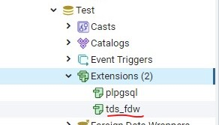

**Step 2: Foreign server Creation**

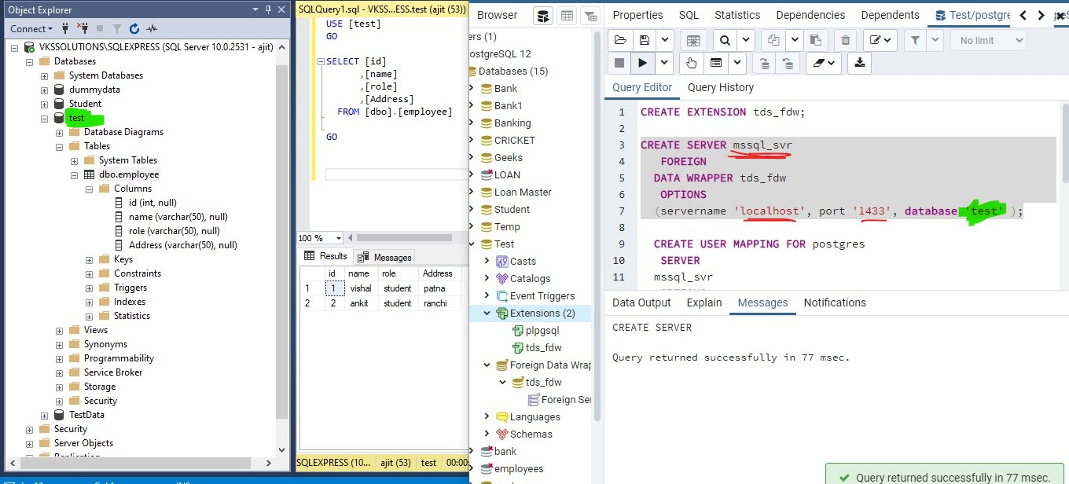

**You will find foreign server you created on foreign servers.**

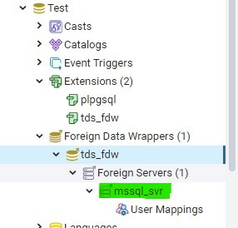

**Step 3: We are going to create userMapping**

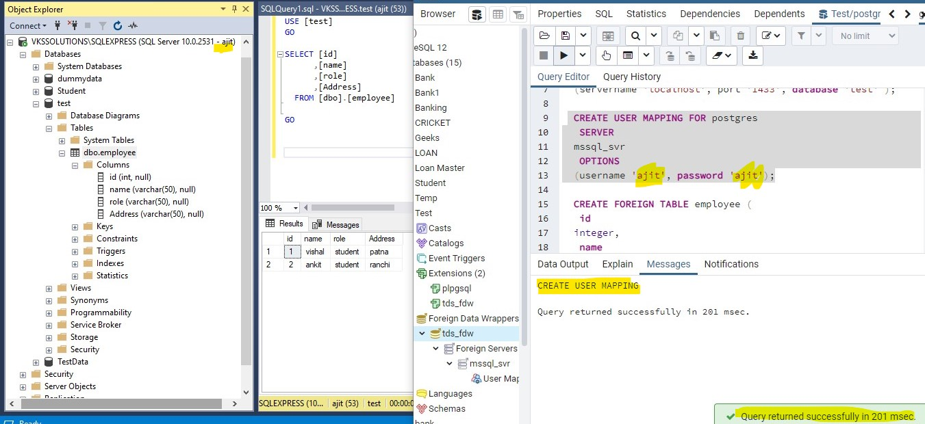

**You can see user Mappings in user Mapping that you have created.**

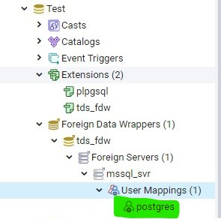

**Step 4: We will create Foreign Table**

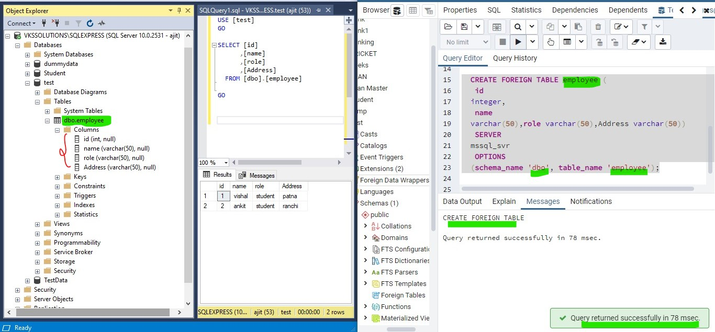

**You can see created Foreign Table**

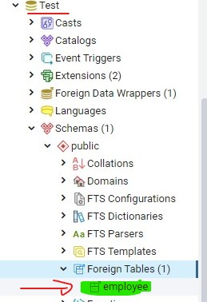

**Step 5: Now we are going to Run a Query to check we can fetch Data .**

